## Create a Node.js web app in Azure App Service

This tutorial shows how to create a simple [Node.js](http://nodejs.org/) application and deploy it to a [web app](https://azure.microsoft.com/en-in/documentation/articles/app-service-web-overview/) in [Azure App Service](https://azure.microsoft.com/en-in/documentation/articles/app-service-value-prop-what-is/) by using [Git](http://git-scm.com/). The instructions in this tutorial can be followed on any operating system that is capable of running Node.js.

You'll learn:

* How to create a web app in Azure App Service by using the Azure preview portal.
* How to deploy a Node.js application to the web app by pushing to the web app's Git repository.

The completed application writes a short "hello world" string to the browser.

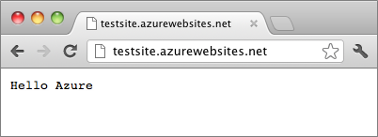

For tutorials and sample code with more complex Node.js applications, or for other topics about how to use Node.js in Azure, see the [Node.js Developer Center](https://azure.microsoft.com/develop/nodejs/).

NOTE:

To complete this tutorial, you need a Microsoft Azure account. If you don't have an account, you can [activate your MSDN subscriber benefits](https://azure.microsoft.com/en-us/pricing/member-offers/msdn-benefits-details/?WT.mc_id=A261C142F) or [sign up for a free trial](https://azure.microsoft.com/en-us/pricing/free-trial/?WT.mc_id=A261C142F).

If you want to get started with Azure App Service before you sign up for an Azure account, go to [Try App Service](http://go.microsoft.com/fwlink/?LinkId=523751). There, you can immediately create a short-lived starter web app in App Service—no credit card required, and no commitments.

Create a web app and enable Git publishing

Follow these steps to create a web app in Azure App Service and enable Git publishing.

[Git](http://git-scm.com/%20target=) is a distributed version control system that you can use to deploy your Azure Website. You'll store the code you write for your web app in a local Git repository, and you'll deploy your code to Azure by pushing to a remote repository. This method of deployment is a feature of App Service web apps.

1. Sign in to the [Azure preview portal](https://portal.azure.com/).
2. Click the **+ NEW** icon on the top left of the portal.
3. Click **Web + Mobile**, and then click **Web app**.

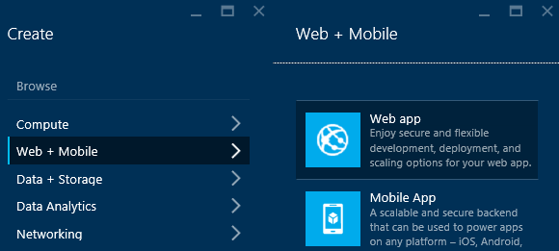

1. Enter a name for the web app in the **Web app** box.

This name must be unique in the azurewebsites.net domain because the URL of the web app will be {name}.azurewebsites.net. If the name you enter isn't unique, a red exclamation mark appears in the text box.

1. Select a **Subscription**.
2. Select a **Resource Group** or create a new one.

For more information about resource groups, see [Using the Azure Preview Portal to manage your Azure resources](https://azure.microsoft.com/en-in/documentation/articles/resource-group-portal/).

1. Select an **App Service plan/Location** or create a new one.

For more information about App Service plans, see [Azure App Service plans overview](https://azure.microsoft.com/en-in/documentation/articles/azure-web-sites-web-hosting-plans-in-depth-overview/)

1. Click **Create**.

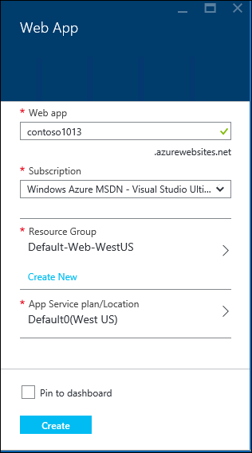

In a short time, typically less than a minute, Azure finishes creating the new web app.

1. Click **Web apps > {your new web app}**.

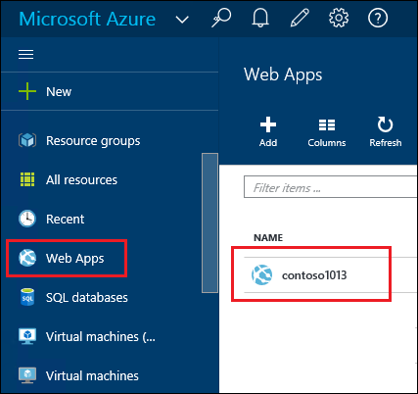

1. In the **Web app** blade, click the **Deployment** part.

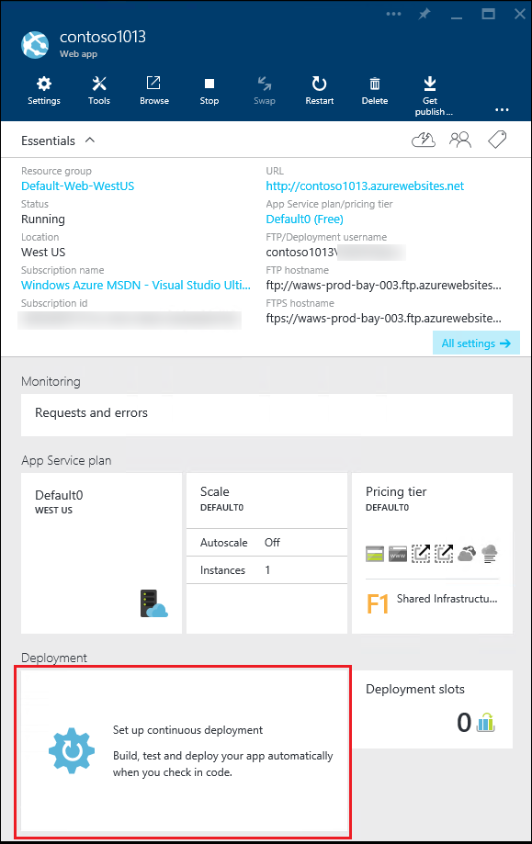

1. In the **Continuous Deployment** blade, click **Choose Source**
2. Click **Local Git Repository**, and then click **OK**.

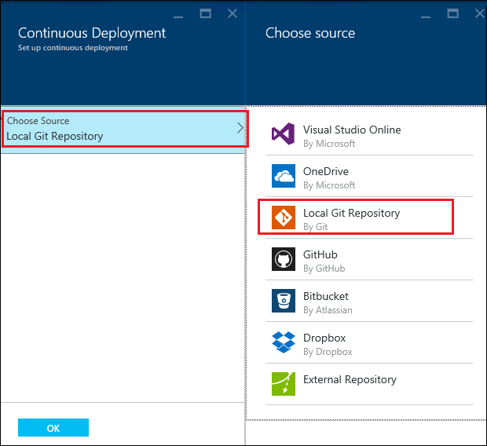

1. Set up deployment credentials if you haven't already done so.

a. In the Web app blade, click **Settings > Deployment credentials**.

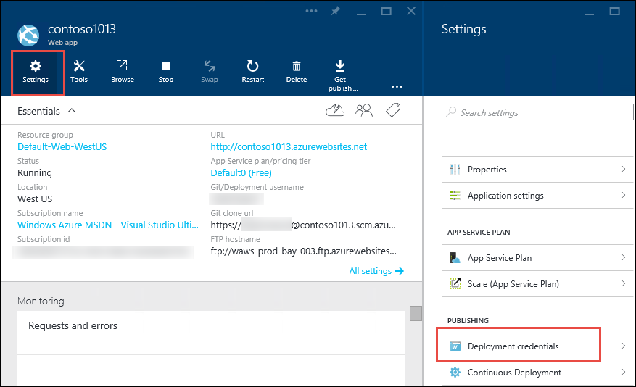

b. Create a user name and password.

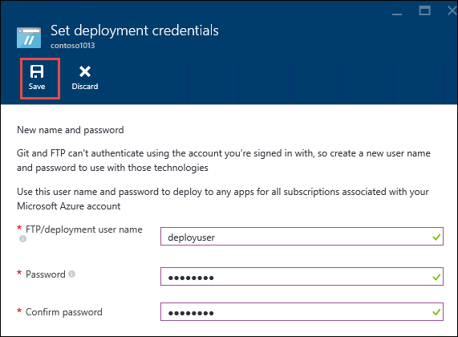

1. In the Web app blade, click **Settings**, and then click **Properties**.

To publish, you'll push to a remote Git repository. The URL for the repository is listed under **GIT URL**. You'll use this URL later in the tutorial.

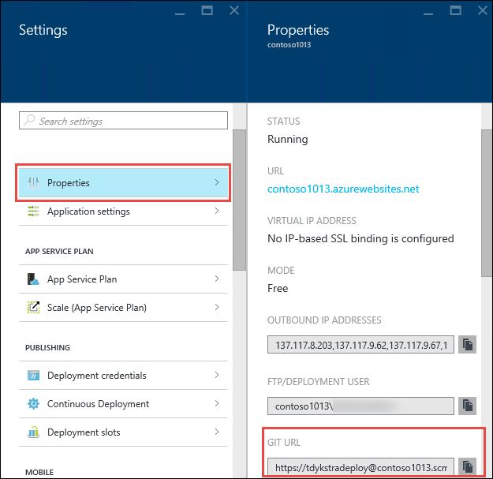

Build and test your application locally

In this section, you'll create a **server.js** file that contains a slightly modified version of the 'Hello World' example from [nodejs.org]. The code adds process.env.PORT as the port to listen on when running in an Azure web app.

1. Create a directory named *helloworld*.
2. Use a text editor to create a new file named **server.js** in the *helloworld* directory.
3. Copy the following code into the **server.js** file, and then save the file:

Copy to clipboardCopy

var http = require('http')

var port = process.env.PORT || 1337;

http.createServer(function(req, res) {

res.writeHead(200, { 'Content-Type': 'text/plain' });

res.end('Hello World\n');

}).listen(port);

1. Open the command line, and use the following command to start the web app locally.

Copy to clipboardCopy

node server.js

1. Open your web browser and navigate to http://localhost:1337.

A webpage that displays "Hello World" appears, as shown in the following screenshot.

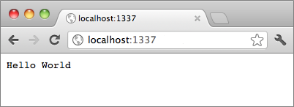

Publish your application

1. Install Git if you haven't already done so.

For installation instructions for your platform, see the [Git download page](http://git-scm.com/download).

1. From the command line, change directories to the **helloworld** directory and enter the following command to initialize a local Git repository.

Copy to clipboardCopy

git init

1. Use the following commands to add files to the repository:

Copy to clipboardCopy

git add .

git commit -m "initial commit"

1. Add a Git remote for pushing updates to the web app that you created previously, by using the following command:

Copy to clipboardCopy

git remote add azure [URL for remote repository]

1. Push your changes to Azure by using the following command:

Copy to clipboardCopy

git push azure master

You are prompted for the password that you created earlier. The output is similar to the following example.

Copy to clipboardCopy

Counting objects: 3, done.

Delta compression using up to 8 threads.

Compressing objects: 100% (2/2), done.

Writing objects: 100% (3/3), 374 bytes, done.

Total 3 (delta 0), reused 0 (delta 0)

remote: New deployment received.

remote: Updating branch 'master'.

remote: Preparing deployment for commit id '5ebbe250c9'.

remote: Preparing files for deployment.

remote: Deploying Web.config to enable Node.js activation.

remote: Deployment successful.

To https://user@testsite.scm.azurewebsites.net/testsite.git

* [new branch] master -> master

1. To view your app, click the **Browse** button on the **Web App** part in the Azure portal.

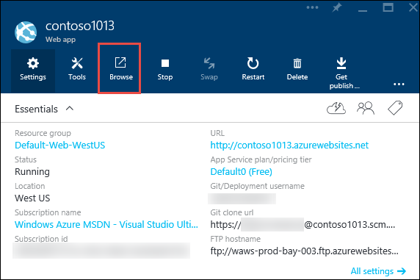

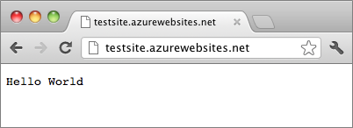

Publish changes to your application

1. Open the **server.js** file in a text editor, and change 'Hello World\n' to 'Hello Azure\n'.
2. Save the file.
3. From the command line, change directories to the **helloworld** directory and run the following commands:

Copy to clipboardCopy

git add .

git commit -m "changing to hello azure"

git push azure master

You are prompted for your password again.

1. Refresh the browser window that you navigated to the web app's URL.



Roll back a deployment

From the **Web app** blade you can click **Settings > Continuous Deployment** to see the deployment history in the **Deployments** blade. If you need to roll back to an earlier deployment, you can select it and then click **Redeploy** in the **Deployment Details** blade.